Name:___Loz # 6__________________

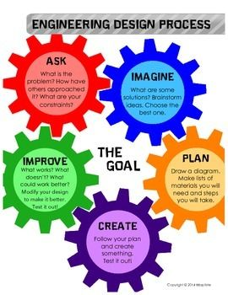

**Pick Your Own Design Challenge**

**What is the challenge?** (2 points)

Write what your challenge will be here: My challenge will be to make a slingshot

**What materials will you use? (2 points)**

I will use

a branch

rubber bands

a penny

scissors

Felt

and staples.

**Imagine and Plan: (2 points)**

1. How will you build it? I will build the slingshot by using a branch as the support. The rubber bands will work as a flexible lever to launch the penny. Next, I will use scissors to cut the felt into a holder for the penny. The penny will be used as the thing we launch. The staples will be used to staple the felt so it will stay on the rubber band. The felt will be used for the launcher in the slingshot.

**Create: Build your design (3 points)** 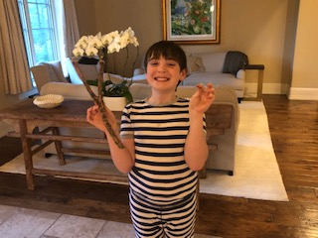

1. Build your design and take a picture of it.

**Test: (4 points)**

1. How are you going to test your design? I am going to test my design by seeing if it is stable so it doesn’t fall apart. I'm also going to test how far my slingshot can shoot.

**Evaluate: (4 points)**

1. What worked well in your design? Give at least three specific things and tell me how or why each thing worked well. For example, do not not say binder clips worked well, instead explain how you used binder clips to make them work well. Please be detailed. One thing that worked well was how strong the stick was. The stick was very strong so it didn’t break or bend. This created the resistance needed to launch the penny. The second thing that worked well was how the rubber bands had just the right amount of tension. The rubber bands stayed on tight and didn’t fall off. The final thing that worked well was how the felt helped me grip the penny. The felt held the penny in place while I launched so it didn’t fall.
2. What could you do to improve your design? To improve my design I could make the rubber band longer and stretchier.

**Reflect: (3 points)**

1. What are three things you learned during our weekly design challenges? One thing I learned during our weekly design challenges was how to make things that I never made before. Another thing I learned was how to design stuff my own way. The final thing that I learned was how to make the boat float.
2. What would you do differently now that you have experience with design challenges and why? The main thing I would do next time is to get a bigger stick because I could use more rubber bands to launch more pennies.